**Topics: Descriptive Statistics and Probability**

1. Look at the data given below. Plot the data, find the outliers and find out $μ, σ, σ^{2}$

|  |  |
| --- | --- |
| **Name of company** | **Measure X** |
| Allied Signal | 24.23% |
| Bankers Trust | 25.53% |
| General Mills | 25.41% |
| ITT Industries | 24.14% |
| J.P.Morgan & Co. | 29.62% |
| Lehman Brothers | 28.25% |
| Marriott | 25.81% |
| MCI | 24.39% |
| Merrill Lynch | 40.26% |
| Microsoft | 32.95% |
| Morgan Stanley | 91.36% |
| Sun Microsystems | 25.99% |
| Travelers | 39.42% |
| US Airways | 26.71% |
| Warner-Lambert | 35.00% |

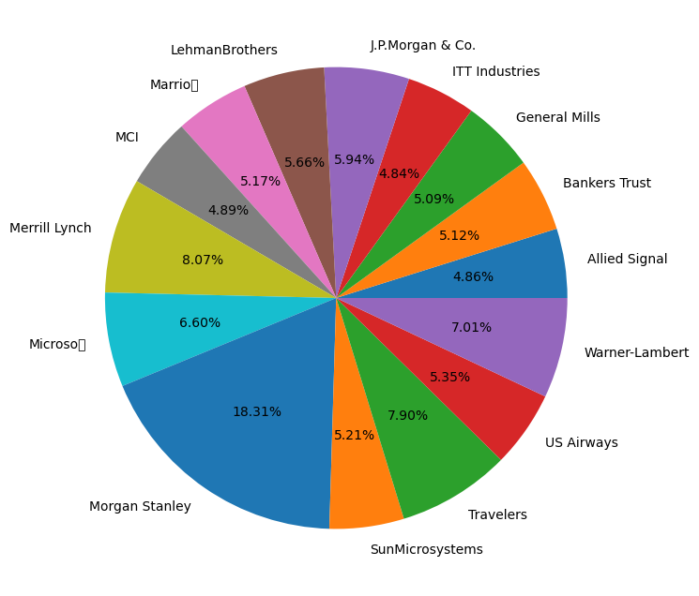

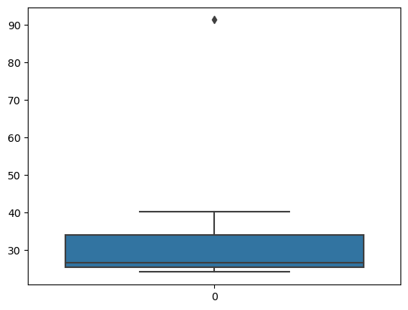



Answer the following three questions based on the box-plot above.

1. What is inter-quartile range of this dataset? (please approximate the numbers) In one line, explain what this value implies.
2. Median = 7

1st quartile = 5

2nd quartile = 12

IQR = (12-5)

= 7

1. What can we say about the skewness of this dataset?
2. Positively skewed
3. If it was found that the data point with the value 25 is actually 2.5, how would the new box-plot be affected?
4. No outliers in the given dataset because of the outlier the data had positive skewness it will reduce and the data will normal distributed.



Answer the following three questions based on the histogram above.

1. Where would the mode of this dataset lie?
2. Lies in between 5 to 10
3. Comment on the skewness of the dataset.
4. Right skewed.
5. Suppose that the above histogram and the box-plot in question 2 are plotted for the same dataset. Explain how these graphs complement each other in providing information about any dataset.
6. By comparing both we can know that the data was right skewed.

We can know all the values of mean, median, mode.

1. AT&T was running commercials in 1990 aimed at luring back customers who had switched to one of the other long-distance phone service providers. One such commercial shows a businessman trying to reach Phoenix and mistakenly getting Fiji, where a half-naked native on a beach responds incomprehensibly in Polynesian. When asked about this advertisement, AT&T admitted that the portrayed incident did not actually take place but added that this was an enactment of something that “could happen.” Suppose that one in 200 long-distance telephone calls is misdirected. What is the probability that at least one in five attempted telephone calls reaches the wrong number? (Assume independence of attempts.)
2. probability of call getting misdirected = 1/200

probability of not getting misdirected = 1-(1/200)

= 199/200

Probability of getting atleast one in 5 attempted call reaches the wrong number is

= 1-(199/200)*5

= 0.025

1. Returns on a certain business venture, to the nearest $1,000, are known to follow the following probability distribution

|  |  |
| --- | --- |
| x | P(x) |
| -2,000 | 0.1 |
| -1,000 | 0.1 |
| 0 | 0.2 |
| 1000 | 0.2 |
| 2000 | 0.3 |
| 3000 | 0.1 |

1. What is the most likely monetary outcome of the business venture?
2. The probability of 2000 is 0.3 so it is likely monetary outcome of business venture.
3. Is the venture likely to be successful? Explain
4. Yes, total earnings are 800. So it is likely to be successful. Highest probability of 2000 venture. There is a probability of profit of 80%.
5. What is the long-term average earning of business ventures of this kind? Explain
6. The long term avg earning expected value will be more than 800
7. What is the good measure of the risk involved in a venture of this kind? Compute this measure

A) 0 -200.0

1 -100.0

2 0.0

3 200.0

4 600.0

5 300.0

dtype: float64

mean: 133.333

std: 294.39

var: 86666.666